

**School of Advanced Technology**

**Final Year Project**

**Project Specification Report**

Project Title: Virtual Reality Questionnaire Toolkit: Examining Interaction Techniques for Doing Questionnaires in VR

Student Name: Xingbo Wei

Student ID: 1824150

Project field: Human-Computer Interaction

Supervisor: Yue Li

1. **Project Descriptation and Problem Statement**

As the development of the Virtual Reality (VR) technology, head-mounted displays (HMD) are becoming popular. VR has since been applied to many areas such as computer graphics, gaming, or education [1], [2] and during 2020 fourth quarter alone there were over one million Quest 2 units sold worldwide [3]. The notable rise of a new generation of virtual reality (VR) systems opened up new methods and interventions for researchers across different areas. It is vital for VR research and development to understand users’ subjective feedback, which is usually assessed through questionnaires after leaving a VR scene. Questionnaire is one way to evaluate the application which allows product owner or developer to understand its upsides and downsides like measuring presence or immersion from the questionnaire result.

Despite paper questionnaire is a way to evaluate most current application or production. However, traditional appraisal methods have inadequacy. Putze Susanne et al. describes the ﻿switching between VR and physical reality leads to a break in presence [3] ﻿that might alter the outcomes [4]. Embedding question items in the VE offers a way to stay closer to the context of an ongoing experience[5], Putze Susanne et al. [3] ﻿show evidence that in virtual reality questionnaire (INVRQ) are less invasive than out VRQ (OUTVRQ).

In this project I propose Virtual Reality Questionnaire Toolkit (VRQTK), a tool enable questionnaire to be the part of the VR experience and interact with the user and virtual environment (VE) and exploring a suitable VRQTK in VE.

* 1. Related Work

The idea of combine questionnaire into application has already been implement in other fields. Shute embeds questionnaire into a video game named *Re-Mission* to let the survey smoothly[6]. Valentin et al. proposed one of the earliest approaches to measuring presence for VEs [3]. They investigated the effect of questionnaire simulation on the sense of presence within VEs. ﻿Some items, however, contained diversity questions, thus, had to be further refined. Another approach to measuring presence was developed by Slater et al. [7] and Usoh et al. [8] in multiple stud- ies. The Slater-Usoh-Steed (in the following referred to as SUS) questionnaire is based on questions that are variations of one of the three themes: (1) the sense ofbeing in the VE, (2) the extent to which the VE becomes the dominant reality, and (3) the extent to which the VE is remembered as a “place”. The current version of the questionnaire has six items and is the second most cited presence questionnaire applicable for VEs. Dmitry et al [5]. based on previous work and theoretical, compare INVRQs and OUTVRQs and discuss the positive of INVRQ. This indicates that the field may benefit from building awareness and providing guidelines. In order to enhance the effectiveness of VRQ, I intend to test different questionnaire forms to determine the a suitable VRQTK to measure different indicators.

1. **Methodology**

This project will first do a literature review on the research conducted on the area of VRQ and focus on design and experimental process. In this step, all the relevant VRQ method should be collected, for example, the slider block (as shown in Figure 1.) and rating scales (as shown in Figure 2.) are the sample questionnaire interface to collect the user data. Moreover, to make the project more convincing, we will also gather the ﻿eletroxx (EEG) signal to measure the participant brain signal to decate user real interaction [9]. In the last step of the experiment, we will interview participants to prepare for subsequent qualitative analysis.

* 1. **Quantitative Methods**

﻿

After the sample game, we will measure presence in the VE using IPQ on a Likert scale with the subscales *general presence* (GP), *spatial presence* (SP), *involvement* (INV) and *experienced realism* (REAL). Furthermore, we asked the participants to rate the game and the perceived control over on a 10-ticks slider. Meanwhile, the Muse will detect your brain wave and reflect three region: *active*, *neutral* and *calm.* Compare the results of the questionnaire from lateral based on your brain wave data. Quantitative data were analyzed using IBM SPSS Statistics. Appropriate statistical tests will be chosen depending on the data collected. Responses to open questions will be analyzed using content analysis methods.

**3.3 Qualitative Methods**

We will conduct the interview with participants to obtain qualitative evaluiations ofthe design VRQTK. The the qualitative data will be analyzed by using NVIVO. It aims to explore the participants’ attituds of the VRQTK.

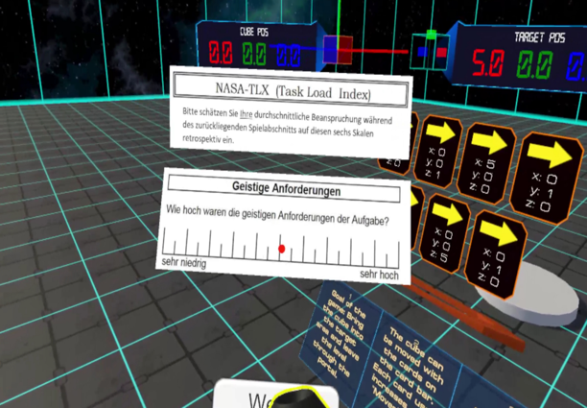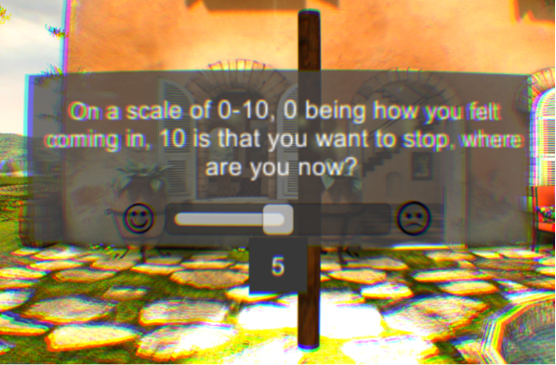

Figure 1. An exmaple of slider box selection. Scale of comfort level ranged from 0 to 10 [10]. Figure 2. An example of rating scale selection with six continuous scales [11].

1. **Project plan (Timeline)**

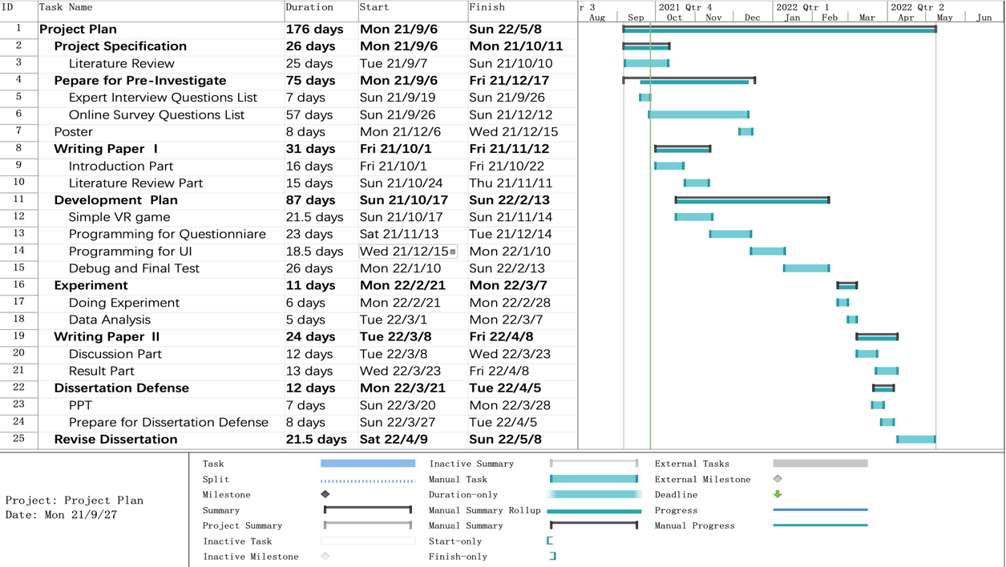The literature review will be conducted to understand the various of VRQ interaction techniques. An appropriate VRQTK will be developed by the end of this semester. At the beginning of next semester, an experiment will be conducted to evaluate user experience with the VRQTK. The data will be processed and analysed and the experiment results will be presented. The project objective is expected to be achived before week 5 in the next semester.

1. **Project deliverables (Expected outcomes)**
2. A summarized report about designing a suitable questionnaire that helps mitigate break in presence in virtual reality.
3. A complete virtual reality questionnaire toolkit (VRQTK) which can be used in different virtual reality environments.

**Project Industrial Relevance:**

Currently, there is no toolkit for questionnaires in the Unity Asset Store. The purpose of this project is to develop a suitable questionnaire toolkit to reduce the pressure on researchers and practitioners in the field of virtual reality, so that they only need to focus on their experience design and development, and this toolkit can be used in their evaluation of user experience.

**References:**

[1] J. Pirker, A. Dengel, M. Holly, and S. Safikhani, “Virtual Reality in Computer Science Education: A Systematic Review,” *Proc. ACM Symp. Virtual Real. Softw. Technol. VRST*, 2020, doi: 10.1145/3385956.3418947.

[2] X. Guo, X. Chen, X. Feng, and S. Zheng, “The Enlightenment of ‘aR / VR’ Technical University Course Education in Taiwan, China,” *ACM Int. Conf. Proceeding Ser.*, pp. 22–28, 2020, doi: 10.1145/3439133.3439146.

[3] S. Putze, D. Alexandrovsky, F. Putze, S. Höffner, J. D. Smeddinck, and R. Malaka, “Breaking the Experience: Effects of Questionnaires in VR User Studies,” *Conf. Hum. Factors Comput. Syst. - Proc.*, pp. 1–15, 2020, doi: 10.1145/3313831.3376144.

[4] V. Schwind, P. Knierim, N. Haas, and N. Henze, “Using presence questionnaires in virtual reality,” *Conf. Hum. Factors Comput. Syst. - Proc.*, pp. 1–12, 2019, doi: 10.1145/3290605.3300590.

[5] D. Alexandrovsky *et al.*, “Examining Design Choices of Questionnaires in VR User Studies,” *Conf. Hum. Factors Comput. Syst. - Proc.*, pp. 1–21, 2020, doi: 10.1145/3313831.3376260.

[6] S. Learning, *Health assessment*. 2014.

[7] V. Schwind, P. Knierim, N. Haas, and N. Henze, “Using presence questionnaires in virtual reality,” *Conf. Hum. Factors Comput. Syst. - Proc.*, vol. 9, no. 5, pp. 497–503, 2019, doi: 10.1145/3290605.3300590.

[8] M. Usoh, “WalkInPlace-p359-usoh.pdf,” pp. 359–364, 1999.

[9] R. M. Winters and S. Koziej, “An auditory interface for realtime brainwave similarity in dyads,” *ACM Int. Conf. Proceeding Ser.*, pp. 261–264, 2020, doi: 10.1145/3411109.3411147.

[10] A. S. Fernandes and S. K. Feiner, “Combating VR sickness through subtle dynamic field-of-view modification,” *2016 IEEE Symp. 3D User Interfaces, 3DUI 2016 - Proc.*, pp. 201–210, 2016, doi: 10.1109/3DUI.2016.7460053.

[11] S. Oberdörfer, D. Heidrich, and M. E. Latoschik, “Usability of gamified knowledge learning in VR and Desktop-3D,” *Conf. Hum. Factors Comput. Syst. - Proc.*, pp. 1–13, 2019, doi: 10.1145/3290605.3300405.

[12] Aslop. (2021, Sep. 8) *Oculus Quest 2 Headset Unit Sales Worldwide From 2020 To. 2021* [Online]. Available:

<https://www.statista.com/statistics/1249850/oculus-quest-2-units-sold-by-quarter/>

[13] Lyons. (2017, Dec. 3) *Rendering Text in WebVR* [Online]. Available:

https://developers.google.com/web/showcase/2017/within